**CREATE AND DEPLOY AZURE SQL DB**

**CREATE TABLES**

**- CUSTOMER**

CREATE TABLE Customers (

 CustomerID INT PRIMARY KEY,

 FirstName VARCHAR(50),

 LastName VARCHAR(50),

 Email VARCHAR(100)

);

select * from customers;

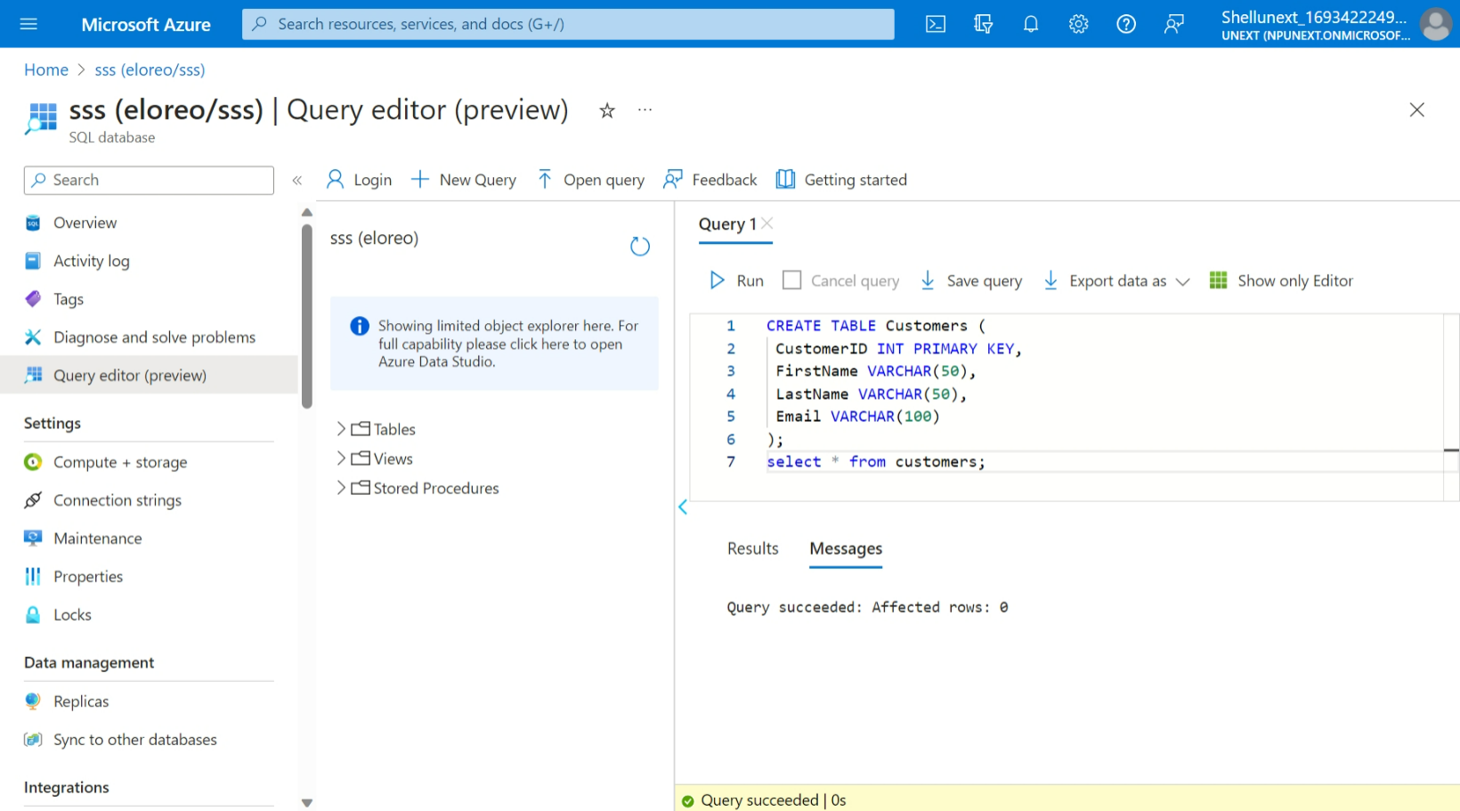

* **ORDERS:**

CREATE TABLE Orders (

OrderID INT PRIMARY KEY,

CustomerID INT,

OrderDate DATE,

TotalAmount DECIMAL(10, 2),

FOREIGN KEY (CustomerID) REFERENCES Customers(CustomerID)

);

SELECT * FROM Orders;

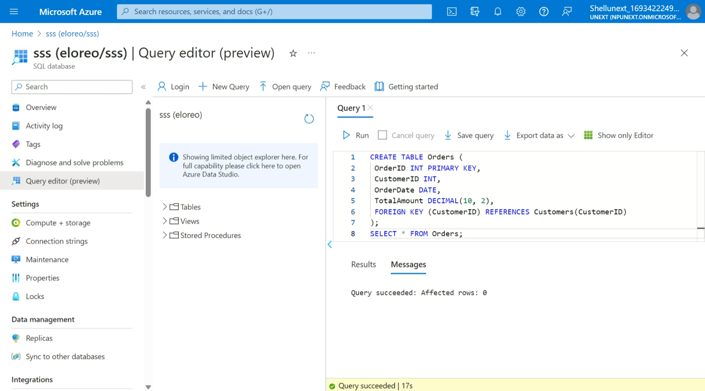

**UNION:**

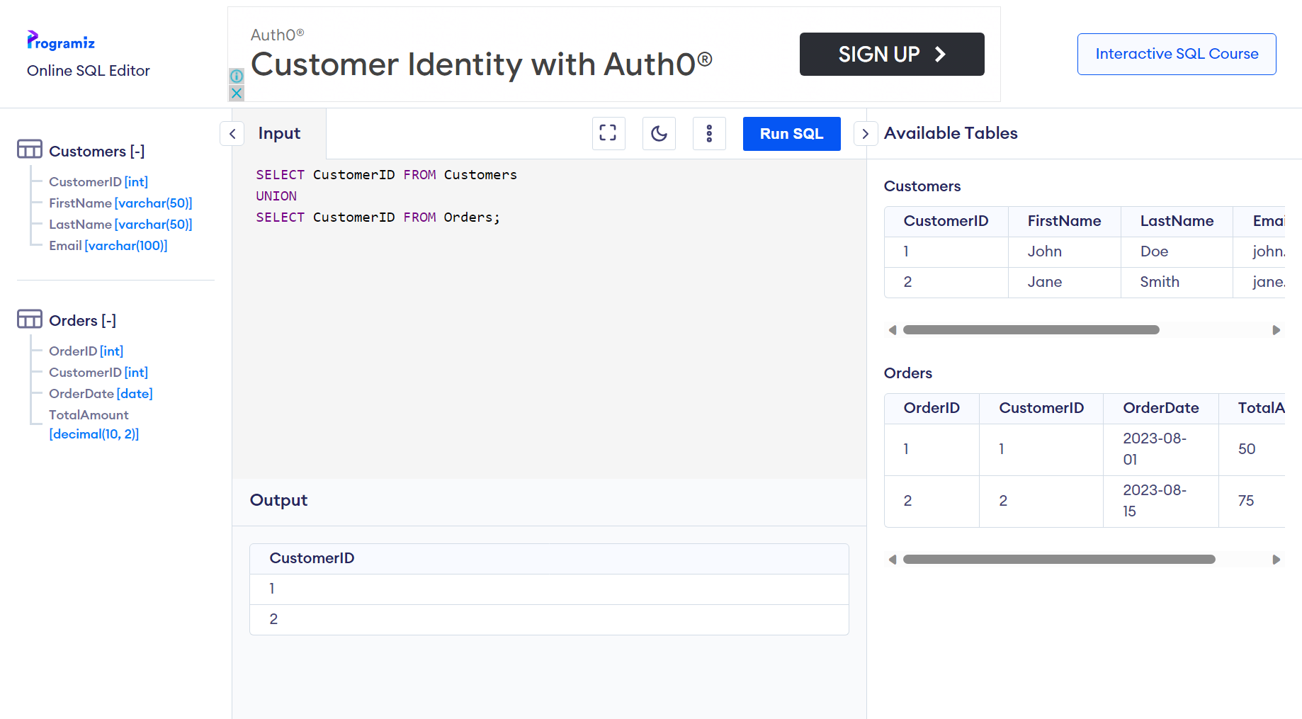

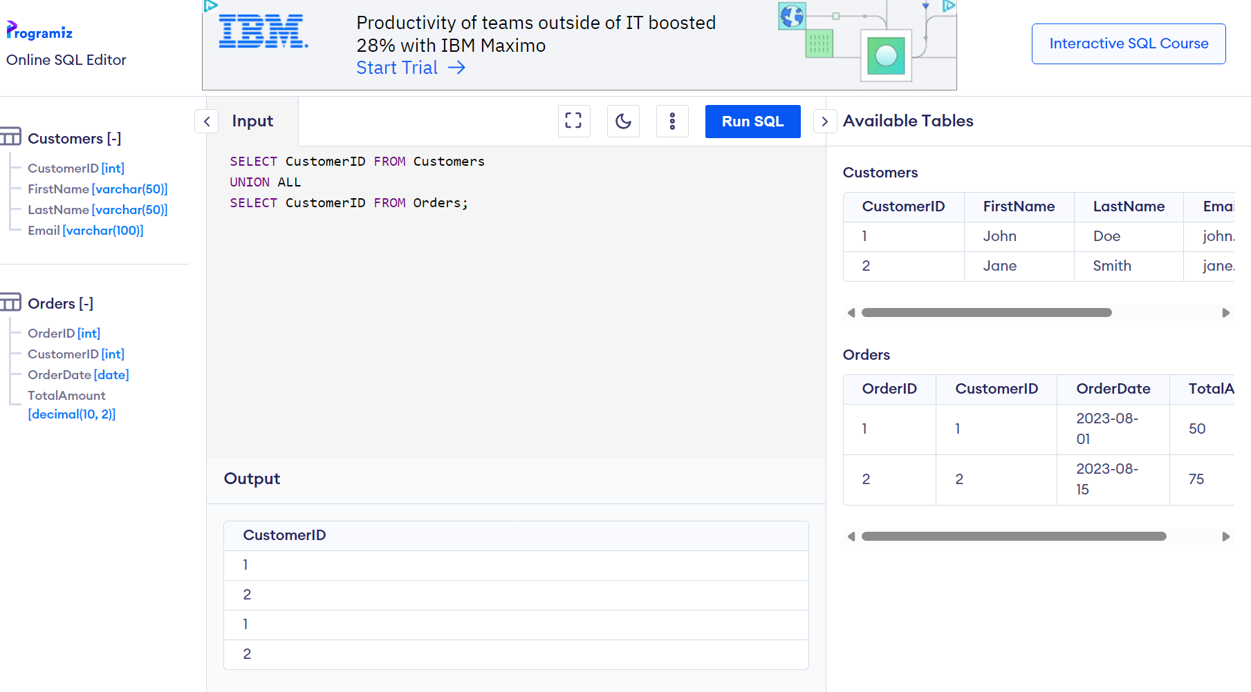

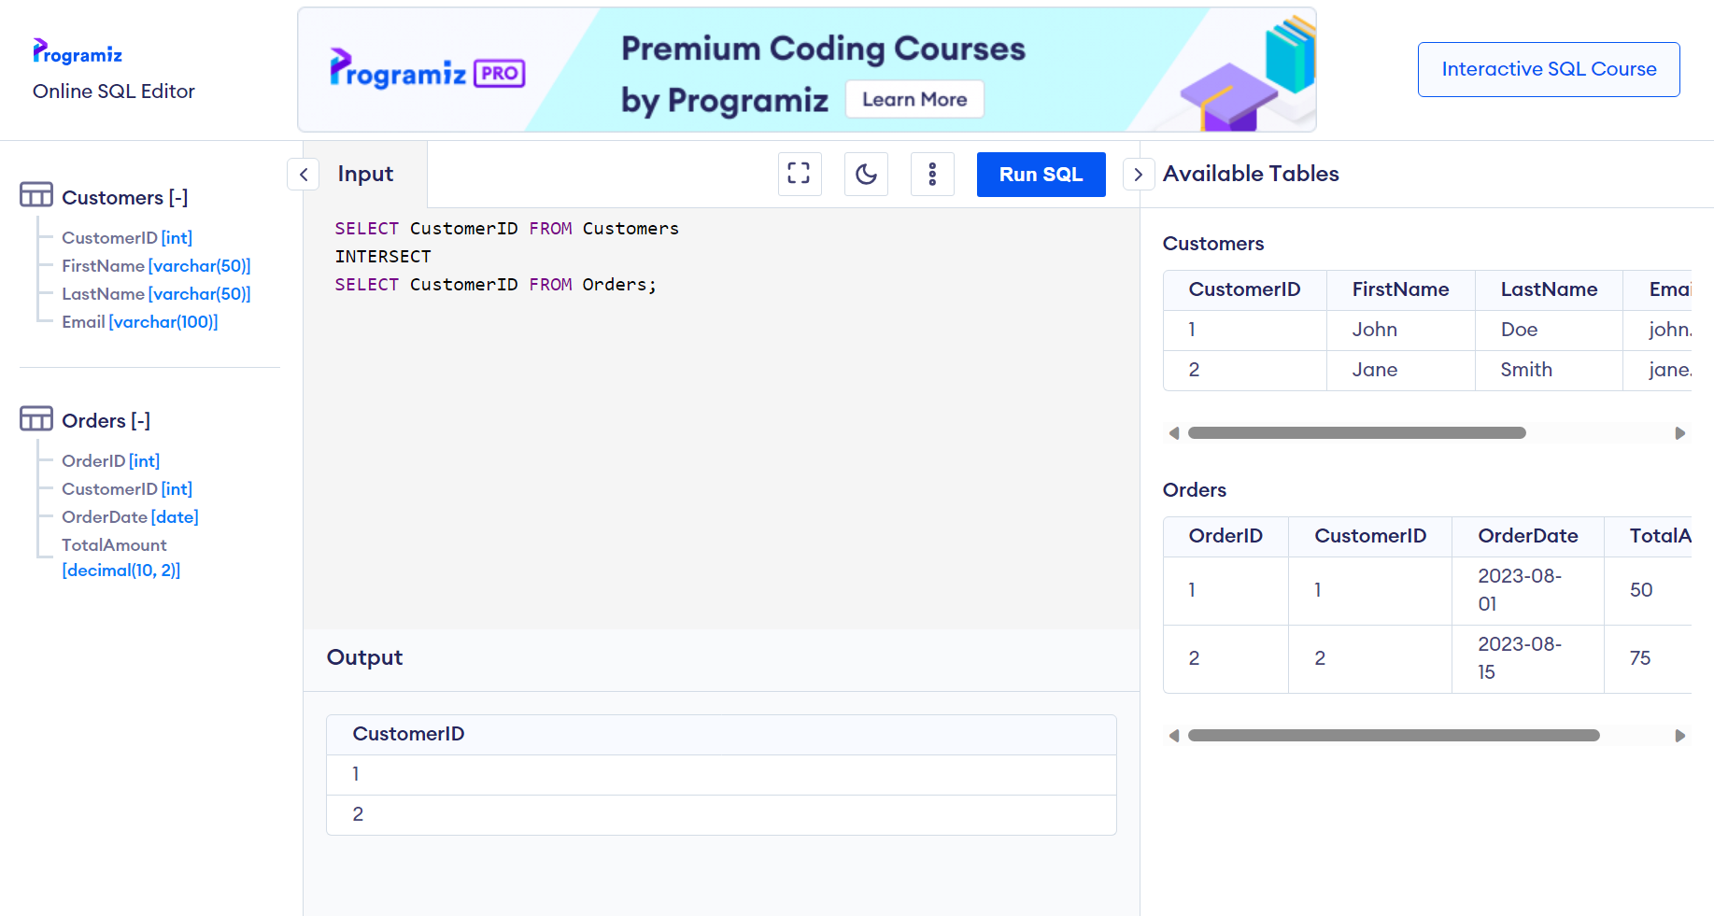

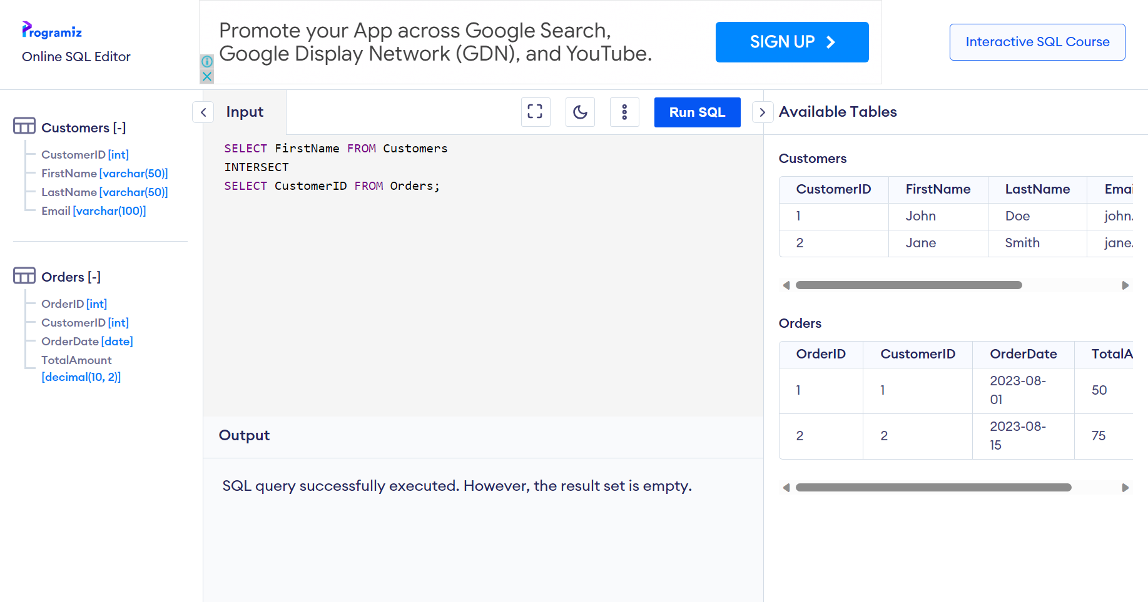

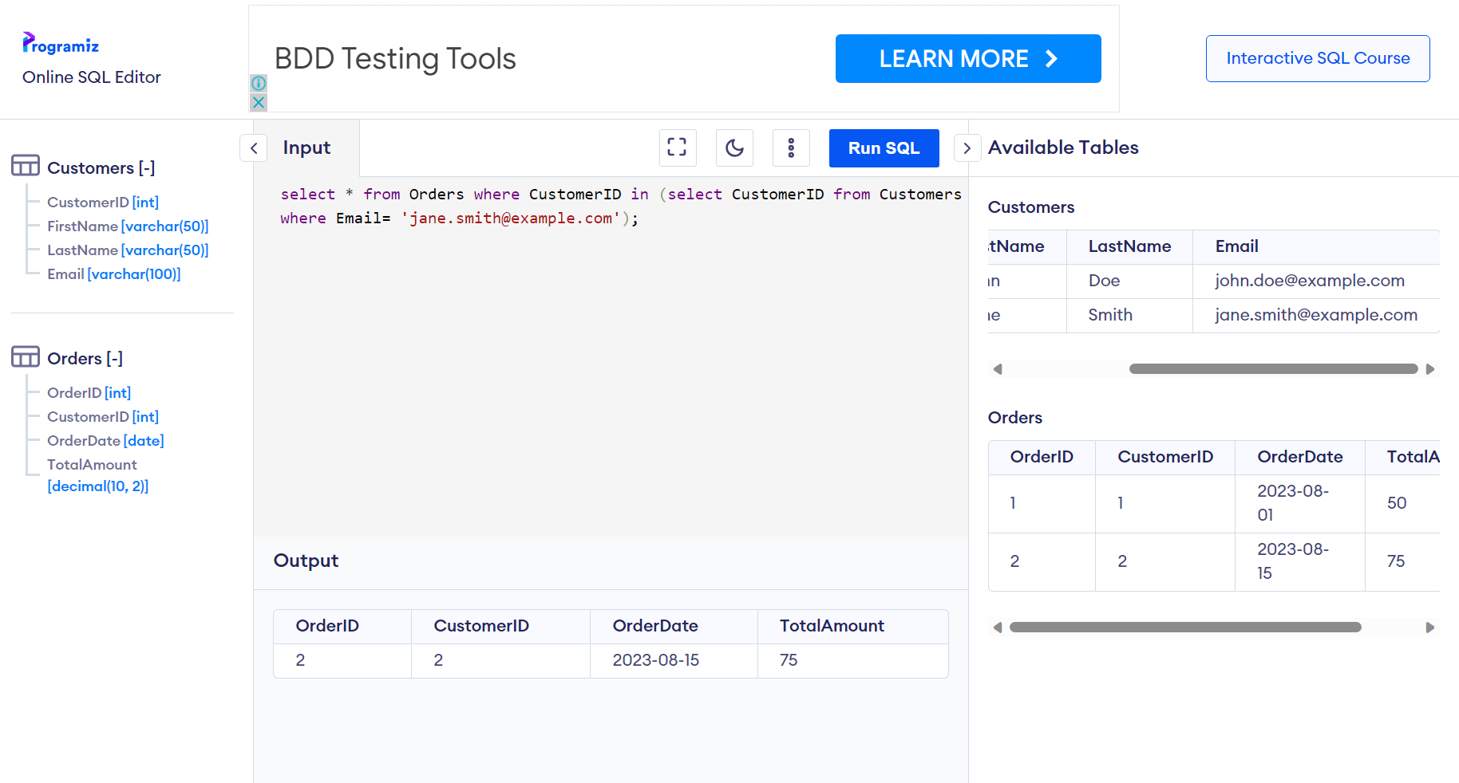

**ADDITIONAL ASSIGNMENT:**

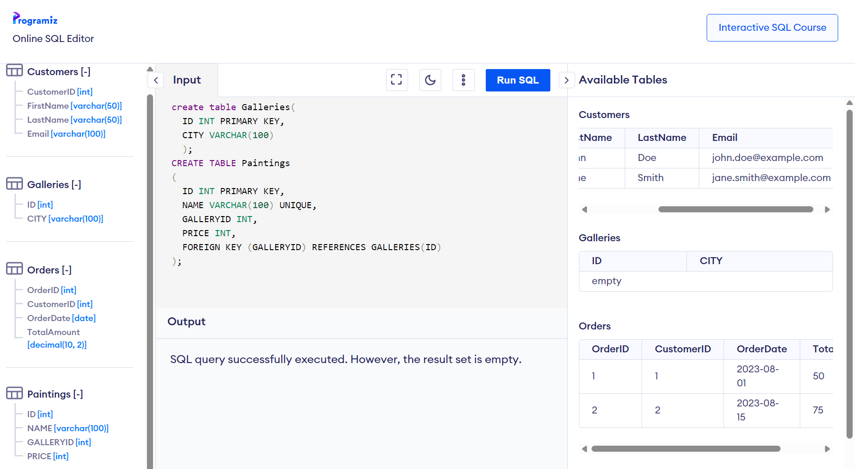

**create table Galleries(**

**ID INT PRIMARY KEY,**

**CITY VARCHAR(100)**

**);**

**CREATE TABLE Paintings**

**(**

**ID INT PRIMARY KEY,**

**NAME VARCHAR(100) UNIQUE,**

**GALLERYID INT,**

**PRICE INT,**

**FOREIGN KEY (GALLERYID) REFERENCES GALLERIES(ID)**

**);**

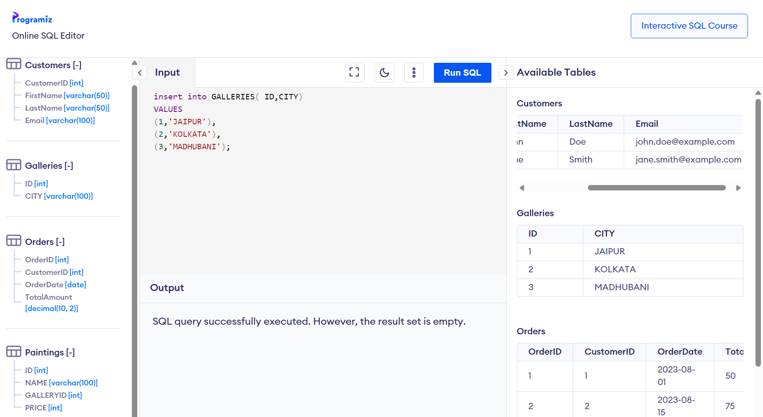

**insert into PAINTINGS( ID,NAME,GALLERYID,PRICE)**

**VALUES**

**(1,'Patterns',3,5000),**

**(2,'Ringer',1,4500),**

**(3,'Gift',1,3200),**

**(4,'Violin Lessons',2,6700),**

**(5,'Curiosity',2,9800);**

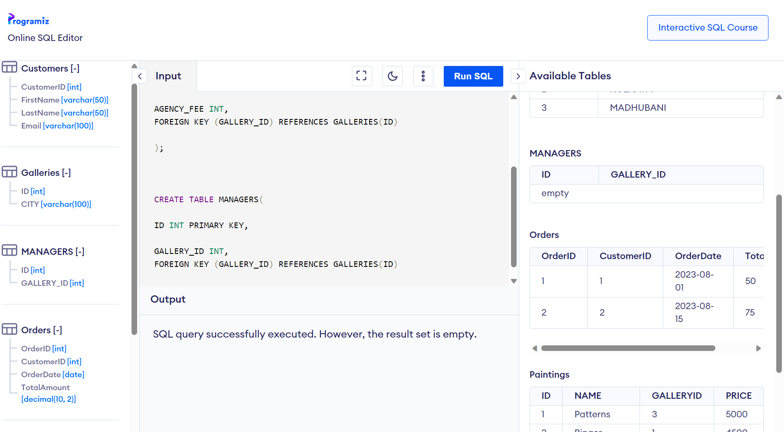

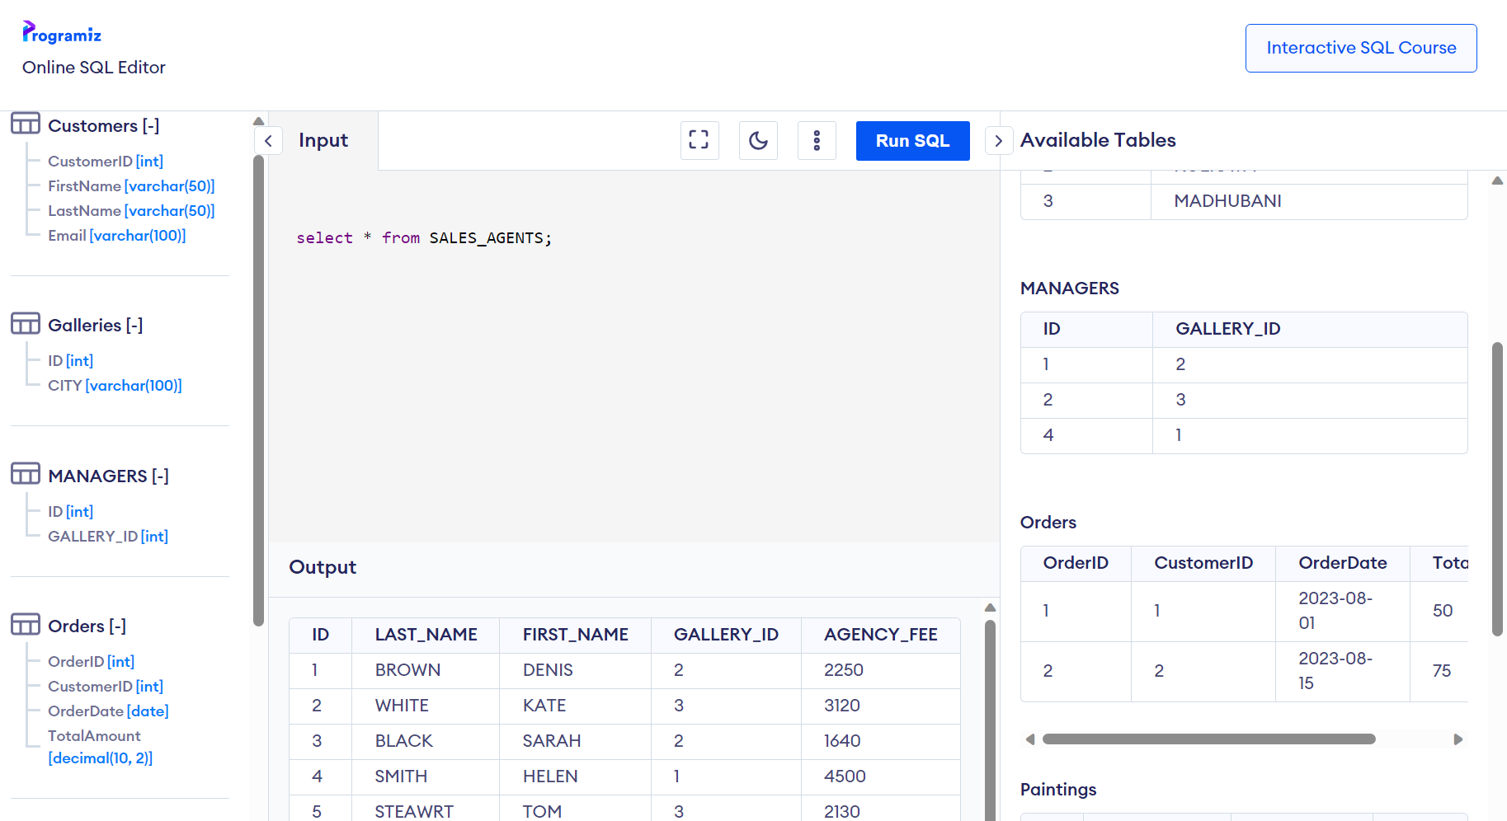

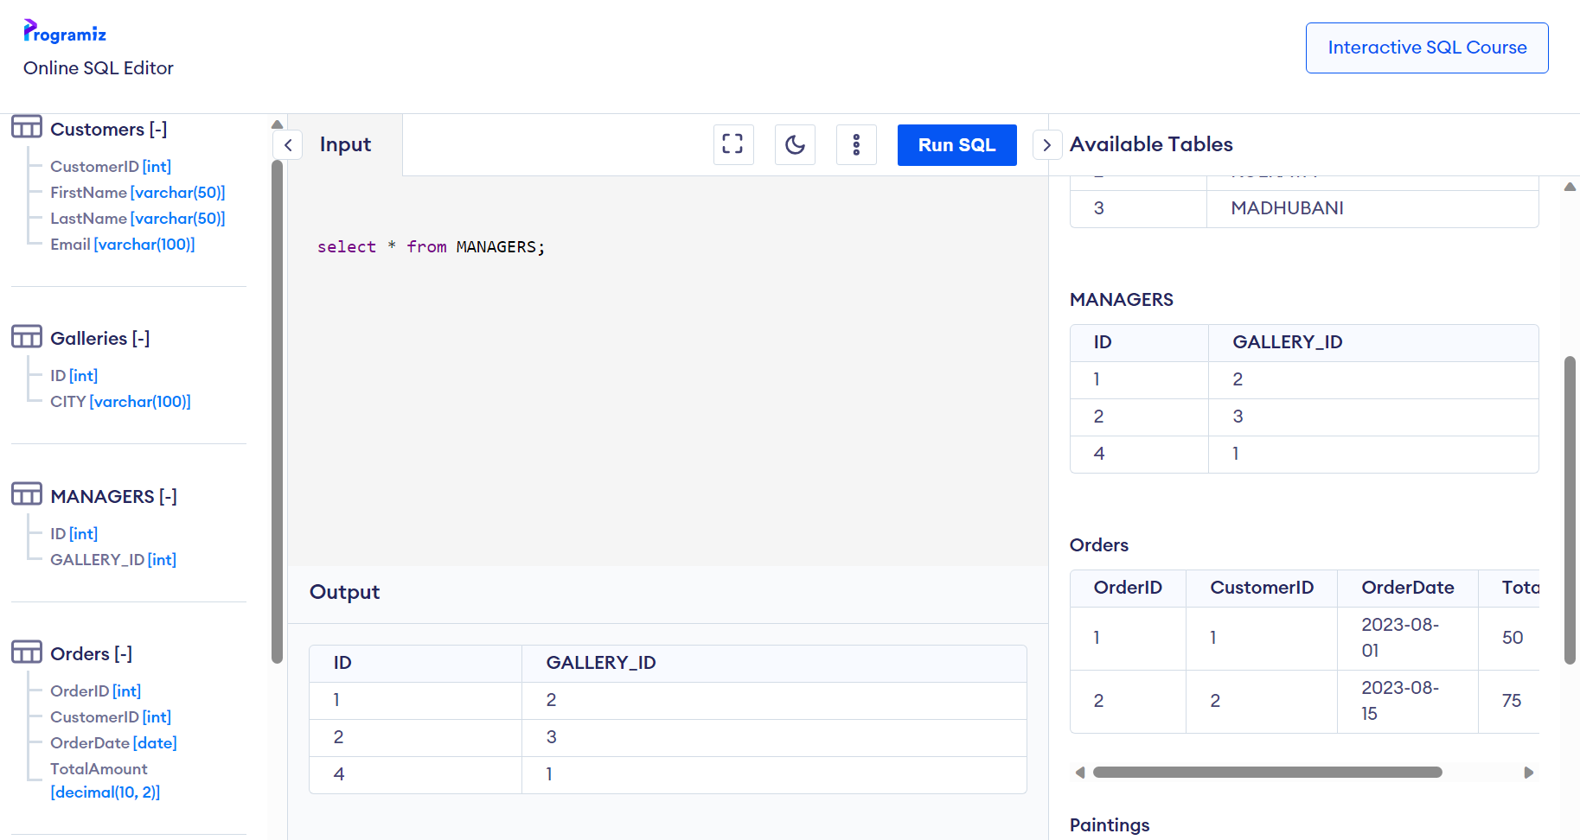

**SELECT NAME, PRICE,(SELECT AVG(PRICE) AS AVERAGE FROM PAINTINGS) AVERAGE FROM PAINTINGS;**

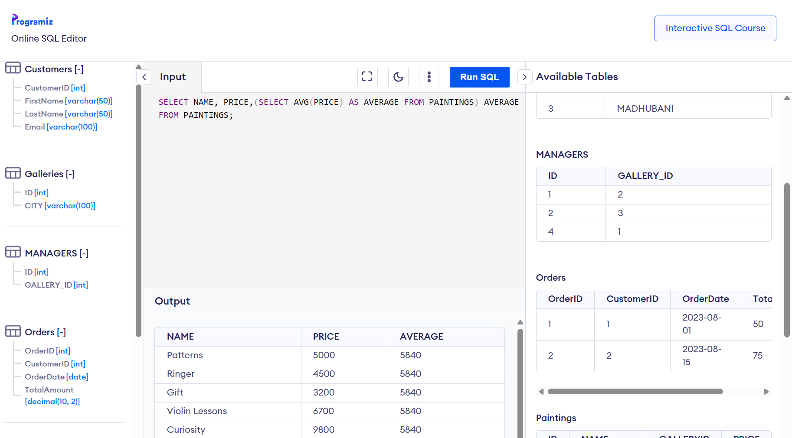

**SELECT * FROM PAINTINGS WHERE PRICE>(SELECT AVG(PRICE) AS AVERAGE FROM PAINTINGS) ;**

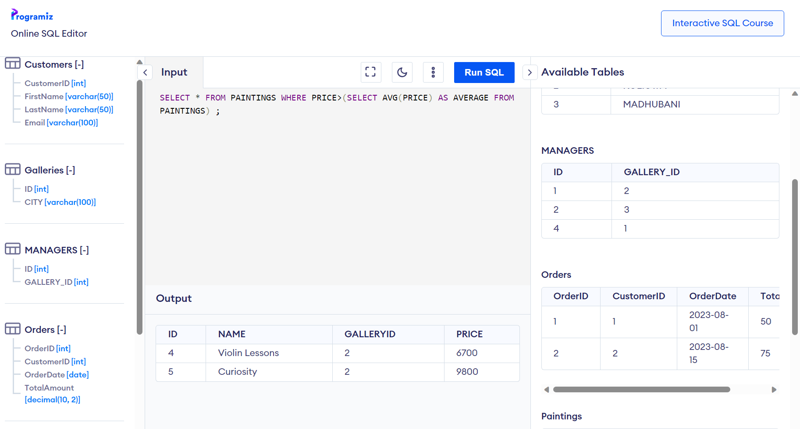

MULTIPLE COLUMN SUBQUERIES:

SELECT ID,NAME,PRICE FROM PAINTINGS TABLE WHERE NAME AND PRICE ARE THE MINIUM PRICE:

SELECT ID,NAME,PRICE FROM PAINTINGS WHERE (NAME,PRICE) IN ( SELECT NAME,MIN(PRICE) FROM PAINTINGS);

(THE ABOVE QUERY WORKS IN OTHER SERVERS)

(FOR AZURE SQL QUERY TO BE WRITTEN IS: )

SELECT ID,NAME,PRICE FROM PAINTINGS WHERE CONCAT(NAME,PRICE) IN ( SELECT CONCAT(NAME,MIN(PRICE)) FROM PAINTINGS GROUP BY NAME)

CO-RELATED SUBQUERIES:

SUBQUERIES THAT RETURN MULTIPLE COLUMNS AS OUTPUT DEPENDING UPON THE INFO OBTAINED FROM THE PARENT QUERY

QUERY WHERE WE HAVE A COUNT OF PAINTING AND CITY NAMES:

SELECT CITY,(SELECT COUNT(*) FROM PAINTINGS P WHERE G.ID = P.GALLERY_ID) COUNT_PAINTINGS FROM GALLERIES G;

FIND OUT THE INFO OF THOSE SALES AGENT WHOSE AGENCY FEES IS GERATER THAN OR EQUAL TO THE AGENCY FEES OF THERE GALLERY

SELECT FIRST_NAME, LAST_NAME,AGENCY_FEE FROM SALES_AGENTS SA1 WHERE SA1.AGENCY_FEE >= (SELECT AVG(AGENCY_FEE) FROM SALES_AGENTS SA2 WHERE SA2.GALLERY_ID = SA1.GALLERY_ID);

Views:

CREATE VIEW VW_PAINTINGPRICE AS

SELECT NAME AS PAINTING,PRICE,(SELECT AVG(PRICE) FROM PAINTINGS WHERE PRICE IN

(SELECT PRICE FROM PAINTINGS WHERE PRICE>=5000)) AS AVG_PRICE FROM PAINTINGS;

SELECT * FROM VW_PAINTINGPRICE;

Upload this file having set of insert statements to your azure sql db after create table:

create table Sales_Order_data(

channel varchar(50) NOT NULL,

sales_order_line_key numeric NOT NULL,

sales_order varchar(50) NOT NULL,

sales_order_line varchar(50) NOT NULL

);

And then upload the text script having all the insert queries and run:

SELECT * FROM [DBO].[SALES_ORDER_DATA] WHERE SALES_ORDER = ‘43659001’

INDEXES:

(FROM PDF)

CREATE TABLE PRODUCTS(

PID INT,

PNAME VARCHAR(100),

CATEGORY VARCHAR(50),

PRICE DECIMAL(10,2),

STOCKQUANTITY INT

);

INSERT INTO PRODUCTS(PID, PNAME, CATEGORY, PRICE, STOCKQUANTITY)

VALUES

(1,'PRODUCT A','ELECTRONICS',499.99,100),

(2,'PRODUCT B','CLOTHING',39.99,250),

(3,'PRODUCT C','ELECTRONICS',899.99,50)

SELECT * FROM PRODUCTS;

/* CLUSTERED INDEX*/

CREATE CLUSTERED INDEX IX_PRODUCTID ON PRODUCTS(PRODUCTID);

/* NON CLUSTERED INDEX*/

CREATE NONCLUSTERED INDEX IX_PRODUCTID ON PRODUCTS(CATEGORY);

/* COLUMNSTORE INDEX*/

CREATE NONCLUSTERED COLUMNSTORE INDEX CS_PRICE ON PRODUCTS (PRICE);